|  |
| --- |
| SG Holidays |

Singapore is well known for embracing multiculturalism. Public holidays in Singapore takes into consideration of ethnicity and religion. This further reinforce that every creed and race are celebrated together.

The app below will display the public holidays which fall under secular category. The holidays should be displayed neatly.

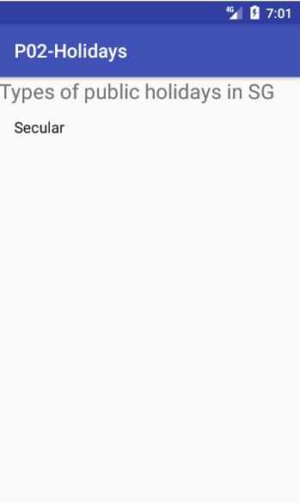 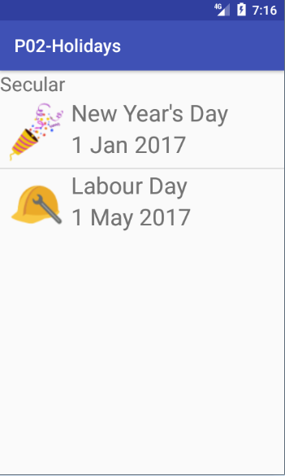 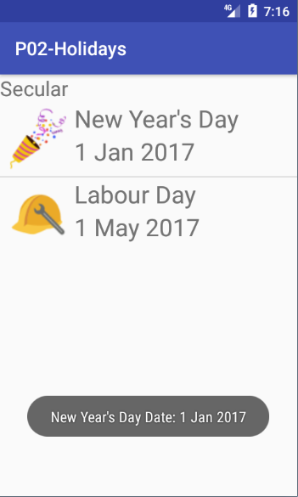

The app should look like the image above with

1. An image representing the holiday will be shown
2. Holiday name

All holidays are to be neatly presented in a ListView.

Note: <http://www.mom.gov.sg/employment-practices/public-holidays>

## Intermediate Enhancement

1. When user clicks on a holiday, show a brief introduction of the holiday in a Toast.

## Advanced Enhancement

1. Add a new category to the first activity named **Ethnic & Religion** and show the public holidays which fall under the category.

